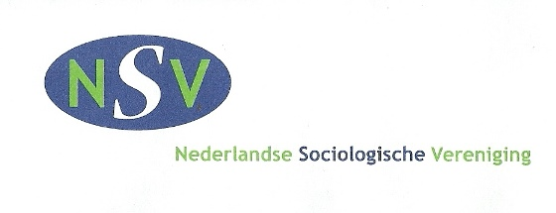
On 10 June 2021, the 20th Day of Sociology will take place. This year the conference is organized by the Department of Sociology at Utrecht University, the Dutch Sociological Association (NSV) and the Flemish Association for Sociology (VVS). Because of the ongoing coronavirus crisis, the conference will take place online this year.
As usual, the program consists of a mix of thematic sessions, a plenary session, followed by the ceremony for the NSV-awards during online informal drinks. During this annual meeting, more than 150 sociologists have the possibility to present their research and discuss the findings with their colleagues. The meeting will be organized in parallel sessions.
The Call for Papers will be launched as of February 15, 2021. In order to allow for more in-depth or specialized discussions, it is possible to propose thematic panels up until February 1, 2021. A panel ideally consists of four papers and a session chair, although other formats are possible. Panels can be held in either Dutch or English.
When proposing a panel, you can optionally include up to 4 papers. It is also possible to propose an ‘open’ panel, to which papers can be submitted later on. If there are not enough paper submissions for a panel, the panel might be combined with another panel.
The session proposals should be submitted to dvds2021@nsv-sociologie.nl by 1 February 2021 at the latest. The following information should be included:
- Title and abstract (max. 300 words) of the session;
- Name and contact information of the session chair;
- Max. 4 proposals for papers: name of the author(s), title of the paper, and abstract (max. 300 words)
- Language of the panel
The session chairs will be informed by February 9, 2021 at the latest, prior to the Call for Papers, on the acceptance of their panel.
If you have any questions, please email them to dvds2021@nsv-sociologie.nl.

